*Tactical Trunk Monkey Games*

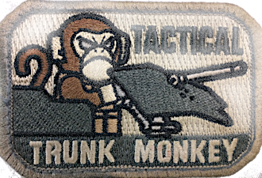

COMP305 – Game Programming 1: Project

Version: 0.5

All work Copyright © 2017 by TTM Games.

All rights reserved

Developed by:

Ilgu Lee | 300851801

Chamsol Yoon | 300808691

Rishav Giri | 300718433

December 22, 2017

Tactical Trunk MonkeY Games

941 Progress Ave, Toronto, ON M1K 5E9

Amso In Space 2

Contents

Version History 3

Game Overview 4

Game Play Mechanics 4

Controls 4

Interface Sketch 5

Title Page 5

Game Screen 5

Background Sprite 6

Stage 1 6

Stage 2 6

Stage 3 6

Player Ship 7

Boss Example 7

Player Weapon “Sample” 8

Levels 9

Level 0: Demo & Tutorial (can be skipped) 9

Story 9

Objective 9

Level 1: The signal 9

Story 9

Objective 9

New Enemy 9

Level 2: Operation Odyssey Dawn 9

Story 9

Objective 9

New Enemy 9

Level 3: Unwelcome Encounter 10

Story 10

Objective 10

Game Over Condition 11

Scoring 11

Upgrades 11

# Version History

|  |  |  |
| --- | --- | --- |
| Version | Detail | Date |
| 0.1 | Project Proposal | 2017-09-20 |
| 0.2 | Specify Game Description | 2017-10-04 |
| 0.3 | First Playable build | 2017-11-29 |
| 0.4 | Alpha   * Modified Title page * Create boilerplates of 3 stages * Develop stage 1 * Develop stage 2 * Conditions to move stage (just rough testing-wise condition) * Added 2 types of enemy, | 2017-12-08 |
| 0.5 | Beta  Enemy spawn pattern logic  Refactor scripts  Boss for stage 2  Player weapon upgrade |  |
|  |  |  |

# Game Overview

Since Saja has known to be defeated by the great journey of Jim and his spaceship, Amso, the peace seemed to have arrived in the universe. But, there are still weird anomalies that grab his attention…

This is a 2D top-down space shooter game. The objective of this game is to travel anomalies in the space, find remaining hostiles spacecrafts, and destroy them. There are multiple levels of stage you can play through, and various options to upgrade your spaceship, Amso.

# Game Play Mechanics

In each level, there will be enemies for you to kill and raise score. Some of them will offer loots that gives points for ship upgrades which will be provided at the dockyard between each stage. At the dockyard, you can make Amso become much faster, stronger, and can even install special weapons, which has limit of amount per a stage.

# Controls

This game uses the keyboard as the default primary of user input. The controls have been mapped to the following controls:



|  |  |
| --- | --- |
| KEY | ACTION |
| Arrow: Left | Move Left |
| Arrow: Right | Move Right |
| Arrow: Up | Move up |
| Arrow: Down | Move down |
| Space | Fire Primary weapon |
|  | pause |

# Interface Sketch

|  |  |
| --- | --- |
| Title Page | Game Screen |
|  |  |

This is vertical scroll game. Player start from lower region, and enemies will spawn upper region basically. Counts of secondary weapon and player life will be displayed each bottom corners of screen. Also, other information such as score will be placed on the top.

## Background Sprite

|  |  |  |
| --- | --- | --- |
| Stage 1 | Stage 2 | Stage 3 |
|  |  |  |

## Player Ship

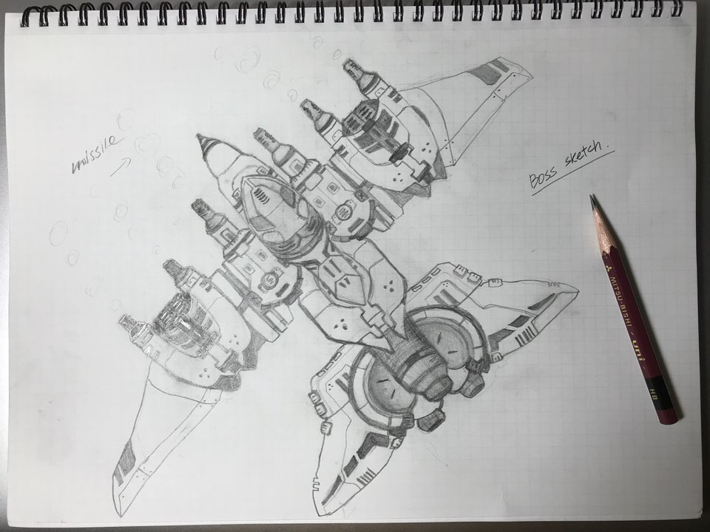

Concept Art of Amso, player ship

## Boss Example

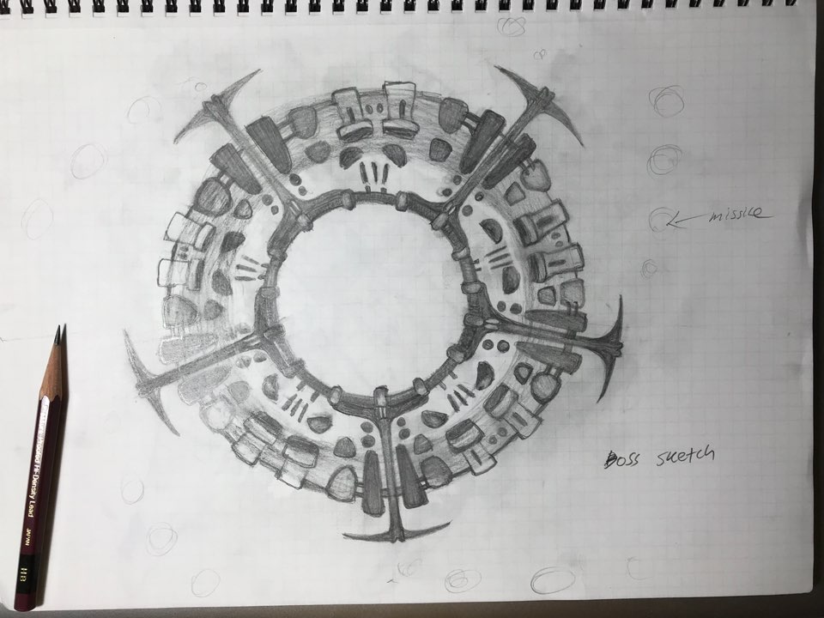

Concept art of Overseer, enemy commander ship

## Player Weapon “Sample”

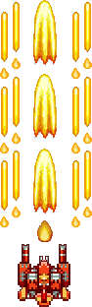

These upgrades will be occurred when the player catches items appear certain moments during playing. Also, some special items will give chance to change weapon type.

# Levels

## Level 0: Demo & Tutorial (can be skipped)

Story

After Saja has been defeated. Amso has taken serious damages. But she has automatic repair module so it will fix herself. Let’s test it out.

Objective

Learn how to control the ship.

## Level 1: The signal

### Story

On way back to home planet, Amso catches some familiar signals that are interpreted as the enemy ships they were fighting against. It should not be existed.

### Objective

Reach to the anomaly point.

### New Enemy

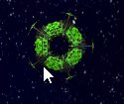

## Level 2: Operation Odyssey Dawn

### Story

After they acquire enemy communication module, they could find that there are enemy bases are being constructed. Jim and Amso decide to strike them before their defenses are fully prepared.

### Objective

Destroy enemy Boss.

### New Enemy

https://i.imgur.com/IqP9kao.png

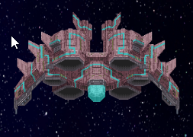

## Level 3: Unwelcome Encounter

### Story

- Censored -

### Objective

Destroy all the enemy.

# Game Over Condition

Every time the player gets hit by an enemies’ weapon/ability or collides with an asteroid he loses life/lives. Depending on the strength of the enemy the player may lose more than one life. When the player has zero lives remaining the journey is over and the player loses.

# Scoring

Each enemy will be differentiated by its type and it will give various scores that player can acquire.

# Upgrades

There will be some items during playing that effects weapon type, ship speed, and secondary weapons.